

**ASSIGNMENT 1 REPORT**

Name:MUHAMMAD AYAZ HASAN

Roll No:20K-1044

Section:BS-SE (5A)

Subject:Software Construction & Development

Date Of Submission:11/9/2022

**Description:**

This java program is implement to solve the equation of Motion.Through this user can easily find the value of Distance(s) by entering values of Initial Velocity(Vi), Time(t) and Acceleration (a).And the System will give the Accurate Result. The Formula of Equation of Motion is:

S=Vit + ½ (a)(t)^2

**Java Swing**

Swing is Java Foundation Class(JFC).This is used in order to create a windows based program.

Java Swing classes used in this program:

**JFrame**

This is used as main windows where different components like button ,textfield is created.

**JTextField**

In this program four objects are declared from JTextField .It will allow editing in a single line text.

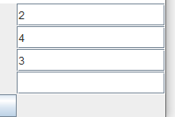

**JLabel**

The object of JLabel is used for adding text in a container.It is used for only reading text.

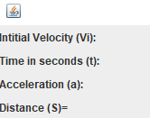

**Result:**

The final Result of the equation will be shown as Below:

